Bug #1: Products cannot be filtered by various categories.

Environment: automationpractice.com production site, Chrome 96

1. Navigate to automationpractice.com

2. Click "Dresses" Category in menu bar under Search and Cart

3. In the left-hand Categories menu, click a filter criterion, such as Yellow under Color

4. Expected Result: Page should refresh and display filtered selection of dresses in the color Yellow.

5. Actual result: Page throws a jQuery error and never updates the displayed selection. See screenshot below:

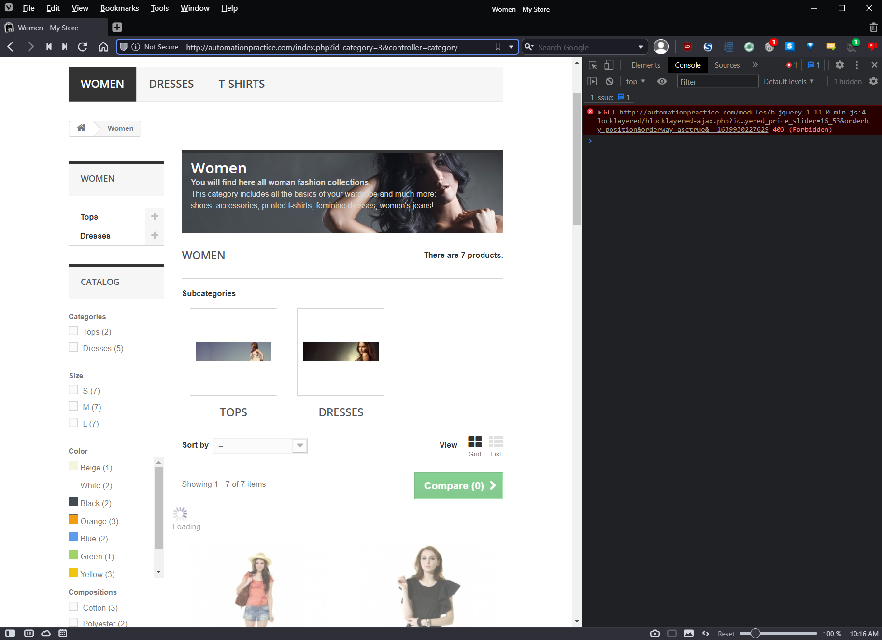

Bug #2: Strange behavior when trying to send Wishlist

Environment: automationpractice.com production site, Chrome 96

1. Navigate to automationpractice.com

2. Verify that you logged in with an account. If not logged in, sign in or create an account.

3. Select a product to navigate to its details page

4. Click the "Add to Wishlist" button. Product is added to wishlist successfully

5. Navigate to the Customer Account page by clicking Account Name in top navigation bar

6. On the account page, click the "My Wishlists" button to open the Wishlists page

7. Click on the wishlist created by adding an item in Step 4.

8. Click the "Send Wishlist" button

Expected result: Page displays a dialog to enter e-mail addresses to send Wishlist to

Actual result: Send Wishlist button expands to fill the width of the page container after one click, does not load dialog for with e-mail address form, needs to be clicked twice. See screenshots below, no errors thrown

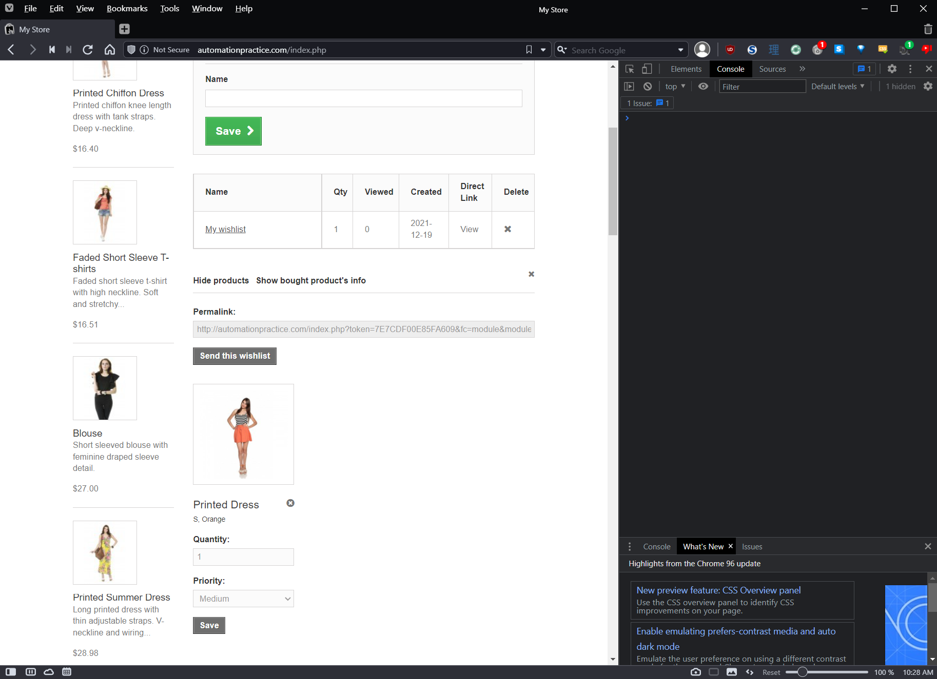

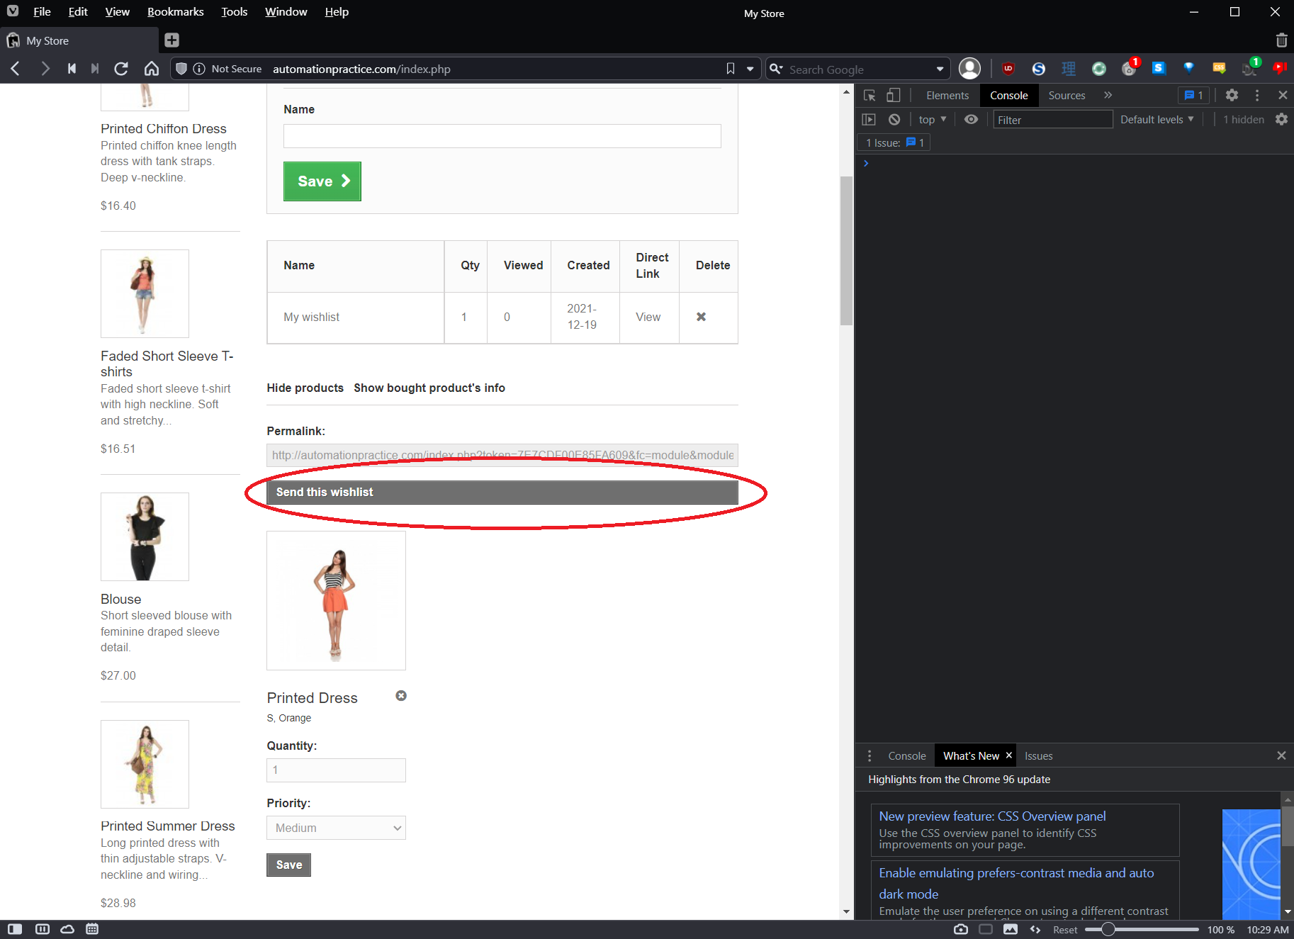

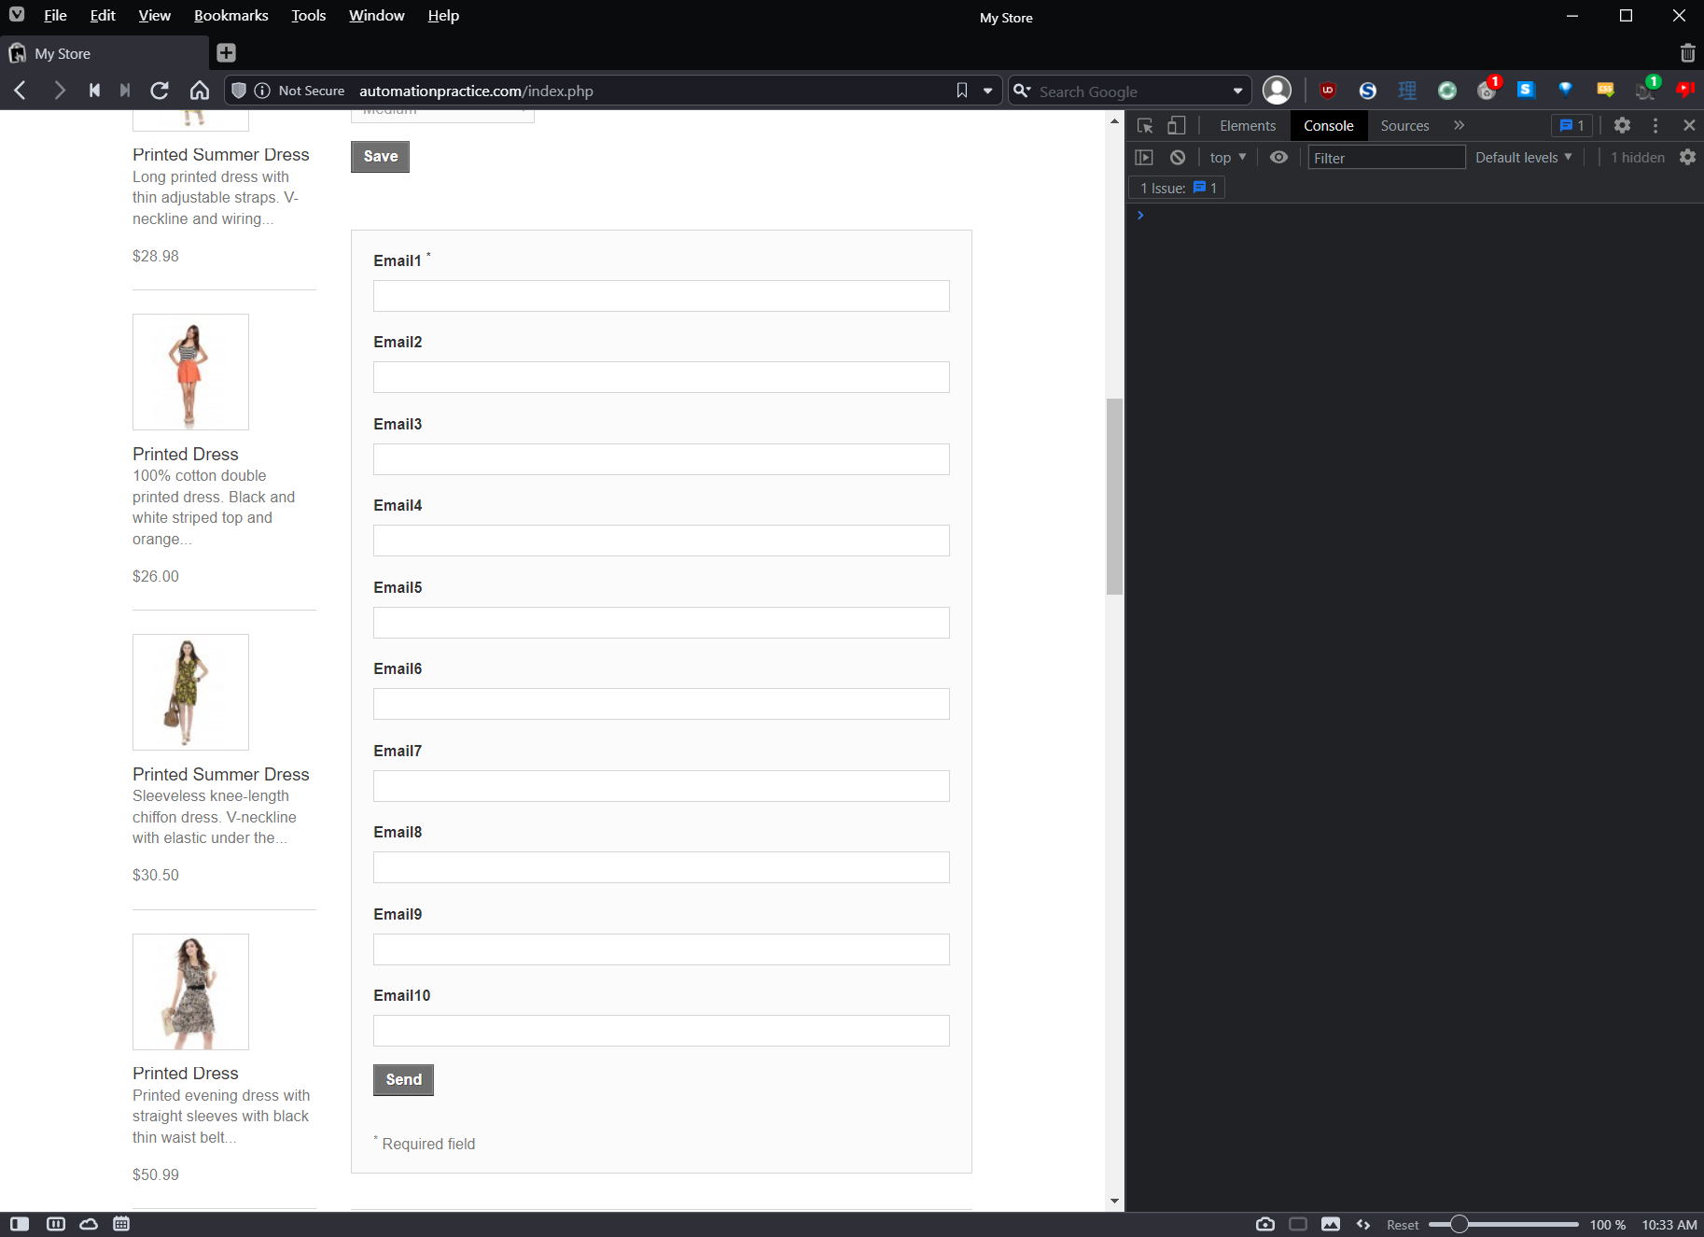

Bug #3: E-mail Wishlist functionality does not seem to work.

Environment: automationpractice.com production site, Chrome 96

Steps to reproduce:

1. Navigate to automationpractice.com

2. Verify that you logged in with an account. If not logged in, sign in or create an account.

3. Select a product to navigate to its details page

4. Click the "Add to Wishlist" button. Product is added to wishlist successfully

5. Navigate to the Customer Account page by clicking Account Name in top navigation bar

6. On the account page, click the "My Wishlists" button to open the Wishlists page

7. Click on the wishlist created by adding an item in Step 4.

8. Click the "Send Wishlist" button twice to load E-mail form (see Bug #2 for more information about this behavior)

9. Enter at least one e-mail address to send to in the Email1 field and click the “Send” button.

Expected result: Page sends a copy of the Wishlist to the e-mail address specified.

Actual result: E-mail form closes and no e-mail is received. This might be an issue with e-mail providers. I tried with two different addresses on different domains and did not get it at either one, but both may have rejected it as spam.

Bug #4: Location search functionality does not work, multiple issues.

Environment: automationpractice.com production site, Chrome 96

Steps to reproduce:

1. Navigate to automationpractice.com

2. Scroll to the links at the bottom and click “Our stores” under Information

3. Page shows locations in Miami area on map. In the “Your location:” text field, enter a zip code for Miami, FL, ex. 33101

Expected result: Page should show information for two stores located in Miami, FL.

Actual result: Page displays a “Not found” message for the zip code entered, multiple errors displayed in console:

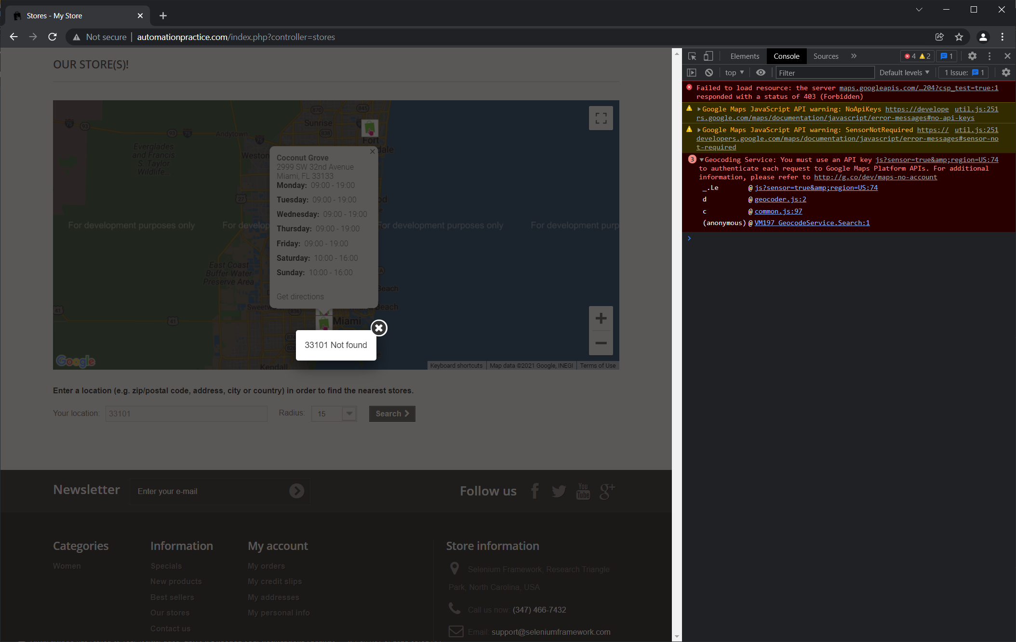

Note: this bug is obviously a result of not having valid Google Maps API keys from the error displayed in the console. This isn’t much of an issue for a site that is only set up for testing purposes, of course. In a real application, however, I feel like this issue should definitely be reported.

Bug #5: User registration allows user to enter unrealistic birthdates, ex. today.

Environment: automationpractice.com production site, Chrome 96

1. Navigate to automationpractice.com

2. Verify that you are not logged in with an account. If logged in, sign out

3. Click “Sign in” on the top information pane next to “Contact us”

4. Enter an address in the “Email address” field on the left under “Authentication” and click “Create Account”

5. In the “Your Personal Information” section on the Create An Account page, enter a recent date such as today’s date, yesterday’s date, or a date from last week in the Date of Birth field.

6. Fill out the rest of the required fields and click “Register” at the bottom

Expected Result: Page should not allow a birth dates for someone who is a baby or child at this point in time.

Actual result: Page accepts birth date and creates account.

Note: the page does have some validation on this field. It will not allow birth dates in the future. Similar bug exists on Personal Information page, which allows the birth date to be updated to today’s date or other recent dates.

